Clinical Skills Certificate for International Pharmacy
Release Date: September 5, 2018
Expiration Date: September 5, 2021
Activity Type: Knowledge-based

Accreditation for Pharmacists
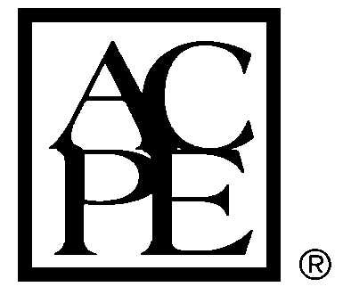
The American Society of Health-System Pharmacists is accredited by the Accreditation Council for Pharmacy Education as a provider of continuing pharmacy education.

Target Audience
This program is intended for pharmacists who are interested in gaining the foundational knowledge necessary to provide clinical pharmacy services in their practice settings. Participants will be assumed to have the required pharmacy content knowledge but not necessarily the education-related knowledge and skills included in this program.

Learning Objectives and Schedule of Activities
Activity CE Information | Title, Description, and Learning Objectives
ACPE #: 0204-0000-18-736-H01-P  Credit Hours: 0.75  Activity Type: Knowledge-based | Title: Diabetes Pharmacotherapy  This module describes pharmacotherapy and management of diabetes mellitus. The module discusses Type 1 and Type 2 diabetes, and hyperglycemic crises, including diabetic ketoacidosis, hyperosmolar hyperglycemic state, and hypoglycemia.  Learning Objectives:  - Describe the difference between type 1 and type 2 diabetes.  - Identify different classes of medications used to treat diabetes.  - Explain how to reduce hypoglycemia and proper treatment of hypoglycemia if needed.  - Define Diabetic Ketoacidosis (DKA) and Hyperosmolar Hyperglycemic State (HHS).  - List first-line medication treatment for DKA and HHS.

Disclosures
In accordance with the ACPE’s and ACCME’s Standards for Commercial Support, everyone in a position to control the content of an educational activity is required to disclose to the accredited provider their relevant financial relationships. An individual has a relevant financial relationship if he or she (or spouse/domestic partner has a financial relationship in any amount occurring in the last 12 months with a commercial interest whose products or services are discussed in the activity content over which the individual has control.

A commercial interest is any entity producing, marketing, re-selling, or distributing healthcare goods or services consumed by, or used on, patients. The Standards for Commercial Support do not consider providers of clinical services directly to patients to be commercial interest.

All planners, presenters, reviewers, and staff report no financial relationships relevant to this activity.

Methods and CE Requirements
Participants must participate in the entire activity and complete the evaluation to earn continuing pharmacy education credit. Follow the prompts online at the ASHP eLearning portal (http://elearning.ashp.org) to claim credit and view statements of credit within 60 days of completing the activity. Credits will be reported directly to CPE Monitor. To verify that you have completed the required steps and to ensure your credits hours have been reported to CPE Monitor, we encourage you to check your NABP eProfile account to validate your credits were transferred successfully before the ACPE 60-day deadline. After the 60 day deadline, ASHP will no longer be able to award credit.

System Technical Requirements
Courses and learning activities are delivered via your Web browser and Acrobat PDF. Users should have a basic comfort level using a computer and navigating web sites.

View the minimum technical and system requirements for learning activities.

Acknowledgements of Support
This activity was planned and developed by The American Society of Health-System Pharmacists.

